

IMPLEMENT PLAN

**Version 1.0**

**Thang Nguyen**

**05/05/2017**

**Revision History**

|  |  |  |  |
| --- | --- | --- | --- |
| **Version** | **Date** | **Author** | **Content** |
| 1.0 | 05/05/2017 | Thang Nguyen | Make Implementation plan document version 1.0 |

Table of Contents

1. INTRODUCTION 6

1.1 Purpose and Scope 6

1.2 Intended audience 6

2. HUMAN RESOURCE 6

2.1 Roles & Responsibility 6

3. IMPLEMENT PROCESS. 7

4. OVERVIEW SCHEDULE 9

5. PRIORITY OF MODULE 9

6. REQUIRE KNOWLEDGE 9

7. IMPLEMENTATION ENVIRONMENT & TOOLS 10

7.1 Environment 10

7.2 Tools 10

8. References 11

**List of Table**

Table 1- Intended Audience **4**

**List of Figure**

Figure 1. Implement Process 7

1. **Introduction.**
   1. **Project Overview**

* The Faculty of Information Technology wants to build a system to support the management of student training and learning. Building a system will take a lot of time and effort, so the department will break down the system into independent parts for implement in many stages. With the desire to inform parents of their children's learning situation, the Faculty will build a module for electronic communication so parents can easily catch information.
  1. **Purpose**
* This document describes in detail the process – which will use to define the Programing Software.
* The process will be started right after the end of Architectural phase, using SRS (Software Requirement Specification) and Detail Design document as the input.
* By the name of this process, the final output will be Process for Coding Phase document.
  1. **. Intend Audience**

|  |  |  |
| --- | --- | --- |
| **Intended Audience** | **Name** | **Reading Suggestions** |
| Implement Leader | * Thang Nguyen | Deploy set of implement process include processes, describes for all member in team can understand and do right process. |
| Programmer | * Nhat Tan * Qui Ngo * Van Phan * Nhuan Tran | Read document to know Implement process and according it to work in Implement phase. |
| Project Manager | * Van Phan | Read to know process of implement phase and tracking progress according to this process. |

Table 1- Intended Audience

1. **Human Resource**
   1. **Role & Responsibility**

|  |  |
| --- | --- |
| **Role** | **Res** |
| Implement Leader | * Make plan & process in implement phase. * Training language programming for all member in team. * Assign task for team member. * Tracking and controlling progress of working in team according to WBS. * Responsibility to code main functions. * Report about progress to Project Management (PM) weekly. * Responsibility to product. * Fix defects if occur |
| Programmer | * Implement the functions of system according to task assigned in WBS and detail design. |

1. **Implement Process**

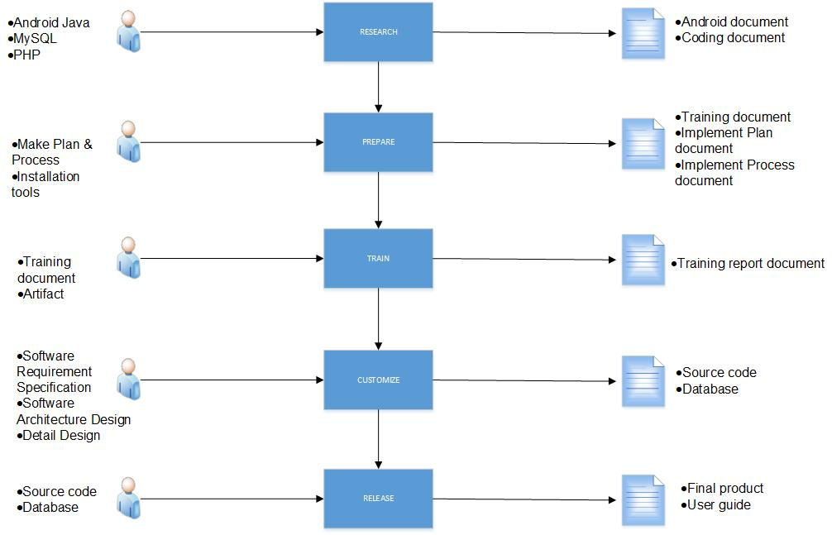

Figure 1. Implement Process

1. **Overview Schedule**
2. **Priority of Module**
3. **Require Knowledge**

Require all member in Team must have knowledge :

* Language : Java Android & PHP .
* Using MySQL, PHP Server , XAMPP

1. **Implementation Environment & Tools** 
   1. **Environment**
   * Run on Window platform : window 7 , 8 and later version
   * Database :My SQL Server
   * Programming language : Android Studio, PHP, MySQL
   * Web browser : Google chrome , FireFox, Internet Explorer
   * Smartphone : Android 5.0 and above
   1. **Tools**

Team will use necessary tool to develop the website system :

* Sublime Text 2 or 3
* Android Studio
* Database My SQL, PHP.

1. **References**